Serverless Architecture
# Source: AI Source: Provided by: [Data Path: Persons Table -> ID Column: 1, Name_En Column: Motasem Essam] -> From: [ChatGPT] on [1/23/2026]
Serverless Architecture is a pattern where developers build and run applications without managing servers. The cloud provider handles infrastructure, scaling, and execution automatically.
👉 You write functions, and the platform runs them on demand

🔑 Key Idea
# Source: AI Source: Provided by: [Data Path: Persons Table -> ID Column: 1, Name_En Column: Motasem Essam] -> From: [ChatGPT] on [1/23/2026]
- No need to manage servers
- Code runs as small functions (Function-as-a-Service – FaaS)
- Automatically scales based on demand

🧱 Structure
# Source: AI Source: Provided by: [Data Path: Persons Table -> ID Column: 1, Name_En Column: Motasem Essam] -> From: [ChatGPT] on [1/23/2026]
Client → API Gateway → Function (FaaS) → Database / External Services
- Client → Web/mobile app
- API Gateway → Receives requests
- Function → Executes business logic
- Cloud Services → Database, storage, messaging

🧩 Example – User Registration
# Source: AI Source: Provided by: [Data Path: Persons Table -> ID Column: 1, Name_En Column: Motasem Essam] -> From: [ChatGPT] on [1/23/2026]
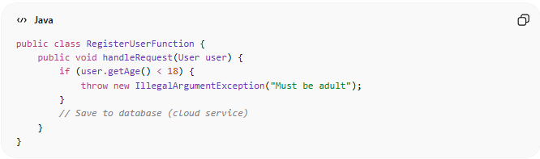
public class RegisterUserFunction {
public void handleRequest(User user) {
if (user.getAge() < 18) {
throw new IllegalArgumentException("Must be adult");
}
// Save to database (cloud service)
}
}
Flow:
User submits form → API Gateway → Function runs → Data stored → Response returned

❌ Bad Example (Traditional Server-Based)
# Source: AI Source: Provided by: [Data Path: Persons Table -> ID Column: 1, Name_En Column: Motasem Essam] -> From: [ChatGPT] on [1/23/2026]
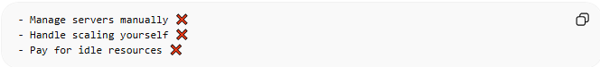
- Manage servers manually ❌
- Handle scaling yourself ❌
- Pay for idle resources ❌

✅ Good Example (Serverless)
# Source: AI Source: Provided by: [Data Path: Persons Table -> ID Column: 1, Name_En Column: Motasem Essam] -> From: [ChatGPT] on [1/23/2026]
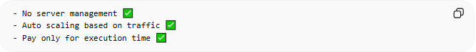
- No server management ✅
- Auto scaling based on traffic ✅
- Pay only for execution time ✅

🔄 Use Cases
# Source: AI Source: Provided by: [Data Path: Persons Table -> ID Column: 1, Name_En Column: Motasem Essam] -> From: [ChatGPT] on [1/23/2026]
- Web APIs and backend services
- Event-driven systems
- File processing (uploads, images)
- Scheduled jobs (cron tasks)

⚠️ Common Mistakes
# Source: AI Source: Provided by: [Data Path: Persons Table -> ID Column: 1, Name_En Column: Motasem Essam] -> From: [ChatGPT] on [1/23/2026]
- Putting too much logic in one function ❌
- Ignoring cold start delays ❌
- Tight coupling between functions ❌

💡 Key Idea
# Source: AI Source: Provided by: [Data Path: Persons Table -> ID Column: 1, Name_En Column: Motasem Essam] -> From: [ChatGPT] on [1/23/2026]
Serverless lets you focus on business logic, while the cloud handles infrastructure and scaling

🧾 Summary
# Source: AI Source: Provided by: [Data Path: Persons Table -> ID Column: 1, Name_En Column: Motasem Essam] -> From: [ChatGPT] on [1/23/2026]
- No server management
- Functions run on demand
- Auto scaling and cost-efficient
- Ideal for modern, cloud-based applications

